CHEMICAL ENGINEERING TRANSACTIONS  VOL. , 2023 | A publication of
The Italian Association
of Chemical Engineering
Online at www.cetjournal.it

Guest Editors: Laura Piazza, Mauro Moresi, Francesco Donsì
Copyright © 2023, AIDIC Servizi S.r.l.
ISBN 978-88-81206-01-4; ISSN 2283-9216

Structured Vegetable Lipids As Ice Cream Fat Source
Ecaterina Savchinaª, Antonella L. Grossoª, Giovanna Ferrentino^{a,}*, Petra Massoner^{b}, Matteo M. Scampicchioª
ªFree University of Bozen-Bolzano, Bolzano, Italy
^{b}A. Loacker Spa, Unterinn, Italy
giovanna.ferentino@unibz.it
This research aimed to develop a low-saturated ingredient as substitute of saturated fats by structuring lipids through a simple enzymatic glycerolysis process. To this purpose, peanut oil (10 g) was mixed with glycerol (1:1 molar ratio) and lipase (0.4 g). The glycerolysis reaction was carried out for 16 h at 65°C under constant stirring. The obtained structured lipid was then used as a fat source in a mixture for the production of ice cream. The mixtures obtained with structured and unstructured peanut oil were compared to a classical cream-based mixture in terms of particle size and ζ-potential. Afterward, the obtained ice creams were assessed based on their physical properties during melting and textural attributes. Glycerolysis of peanut oil reduced the particle size of the formed mixtures, which later created ice creams with a slower melting rate (0.044 g⋅min⁻¹) compared to the peanut oil-based formulation (0.77 g⋅min⁻¹). Similar dripping times were measured for the structured-lipid (60.33 ± 1.2 min) and the cream-based (65.00 ± 1.6 min) ice creams. Moreover, the firmness and consistency of the ice cream made with the structured lipid were not significantly different (p < 0.05) compared to the traditional cream-based product. Overall, the results of the present study clearly indicated that structured lipids could be used as ingredient in ice cream production, paving the way for a partial replacement of saturated fats in food formulations.
  - Introduction
Ice cream is an oil-in-water frozen aerated emulsion containing partially agglomerated fat globules, unfrozen viscous whey, ice crystals, and air bubbles (Calligaris et al., 2018). Fats play an important role in ice cream as structural agents, stabilizing the air phase (Goff & Hartel, 2013) and creating the expected sensory qualities characteristics of the product (Beegum et al., 2022).
However, milk fat is associated with many negative health effects, mainly due to the relatively high content of saturated fatty acids, which could lead to the increase of cholesterol and low-density lipoprotein, thereby increasing the risk of cardiovascular disease (FAO, 2010). The current dietary guidelines (USDA, 2015) recommend the consumption of low-fat dairy products. These recommendations guide consumer choice and put pressure on manufacturers to reduce saturated fats in dairy products in response to consumer demand. Moreover, new requirements imposed by the Food and Drug Administration (FDA) tend to ban partially hydrogenated vegetable fats, remove trans-fatty acids from food products, and reduce saturated fats in foods (FDA, 2018). These new constraints pose significant challenges to develop nutritious lipid-based products with compatible technological characteristics and similar sensory properties.
Vegetable oils are considered healthier and a possible alternative to fats rich in saturated fatty acids. However, they do not have suitable physicochemical properties for direct use in food formulations. Thus, developing fats with low saturated and/or zero trans-fatty acids requires lipid modification techniques to maintain the technological properties of interest.
Among the existing lipid modification methods, enzymatic glycerolysis is one of the most promising techniques. Glycerolysis has the main benefit of being a green process with the ability to preserve the fatty acid composition of the native oil (Nicholson & Marangoni, 2021). During glycerolysis, fatty acid chains located in oil TAGs are interesterified with glycerol molecules, forming mono- and di- acylglycerides (MAGs and DAGs), thus maintaining the same fatty acid composition.
To the best of the authors´ knowledge, no papers have been published so far on the formulation of an ice cream made of structured vegetable oils obtained from an enzymatic glycerolysis process.
Accordingly, the aim of this work was to transform low-melting vegetable oils into high-melting structured fats by an enzymatic glycerolysis process. Peanut oil was used as a substrate for lipase-catalyzed lipid glycerolysis. The obtained structured lipid was then used as a fat source in an ice cream blend and compared to milk fat-based and peanut oil-based formulations. The physical properties of the ice cream blends, as well as the textural and melting properties of the final ice cream, were assessed with the purpose of formulating a low-saturated fat product with minimum impact on its quality attributes.
  - Materials and Methods
2.1 Materials
Ingredients used for the glycerolysis process were: peanut oil, purchased from a local supermarket; glycerol 99.5 % (Sigma Aldrich, St. Louis, MO, USA); non-specific immobilized lipase Novozyme® 435 (Novozymes, Bagsvaerd, Denmark). For the ice cream preparation, the following materials were used: milk cream (40 % fat) and sugar, purchased from a local supermarket; sunflower lecithin and whey powder were kindly provided by A. Loacker Spa. (Unterinn, Italy); guar gum was purchased from Sigma Aldrich (St. Louis, MO, USA).
2.2 Glycerolysis process
Glycerolysis was performed according to the optimized method described by Nicholson & Marangoni, (2020). Briefly, peanut oil (10 g) was mixed with glycerol (1:1 molar ratio) and lipase B from Candida antarctica (0.4 g) under magnetic stirring (200 rpm) for 16 h at 65°C. The resulting mixture was centrifuged at 20 °C and 5,000 rpm for 5 min. Finally, the supernatant phase, constituted by the structured lipids, was collected, flushed with nitrogen, and stored in the dark at -80 °C.
2.3 Ice cream preparation
A cream-based ice cream (CB) was prepared by mixing the following ingredients: pasteurized milk cream (81.1%), sucrose (14%), and stabilizers (lecithin and guar gum added at 0.2% w/w). Two other formulations were prepared by replacing milk cream with an oil-in-water emulsion based on peanut oil (POB) or structured peanut oil (SLB). The fat content of 28% was maintained for all samples. Whey powder was added to adjust the milk-non-fat content to 5%. The liquid blends were heated up to 75 °C for 30 min and mixed thoroughly with high-performance laboratory homogenizer (Digital UltraTurrax T25, IKA, USA) at 11,000 rpm for 2 minutes. The resulting blends were mixed with the dry ingredients, cooled down in an ice bath to 4 °C, and aged for 6 h. Aged ice cream premixes were frozen at –10 °C for 20 min at constant mixing in an ice cream maker (Unold 48816, Montereale Valcellina, Italy). Each batch was then sorted in plastic containers and kept at –25 °C for one week for the hardening stage. The experiments were replicated twice for each blend.
2.4 Ice cream mixture characterization
The ice cream mixture particle size distribution was determined by a static light scattering technique using a Mastersizer Hydro 3000 (Malvern Instruments Ltd., Malvern, Worcestershire, UK). The sample was dispersed dropwise in deionized water until obscuration values of around 10 % were reached. A refractive index of 1.52, and absorption index of 0.01 were used for the measurements. The surface mean diameter D [4,3] and the volume mean diameter D [3,2] were reported as mean and standard deviation from a total number of five measurements. Dv (10), Dv (50) and Dv (90) values were also measured and reported to indicate the width of the size droplet distribution. To determine the ζ-potential, the measurements were conducted at a constant temperature of 25 °C after the ice cream blends were diluted (1:1000) with deionized water.
The ζ-potential of the obtained blends was measured using a Malvern Zetasizer Nano ZS (ZEN 3600) instrument (Malvern Instruments Ltd, Malvern, Worcestershire, UK). Samples were diluted prior to analysis with deionized water (1:1000). The temperature was set to 25 °C for all analyses to avoid multiple scattering effects. The Smoluchowski-Kramers approximation was used to convert electrophoretic mobility to ζ-potential.
2.5 Ice cream physical properties characterization
2.5.1 Stability by multiple light scattering
Turbiscan™ TOWER (Formulation Inc., France) was used to assess ice cream stability while melting. Ice creams were placed in cylindrical glass cells and stored at –18 °C for 24 hours. Before the analysis, vials were dried from the condensate and placed into the tower at 25 °C for 3 h. The light source in the near-infrared at a wavelength of 880 nm scanned the samples every 100 sec. The light transmitted through the sample and the light backscattered by it was received by two optical sensors. From the backscattering spectra, the Turbiscan stability index (TSI) was calculated and reported as a function of time. For each sample, experiments were performed in triplicates.
2.5.2 Meltdown test
The meltdown test was performed in duplicate on ice cream samples stored at –18 °C for 2 weeks. Pre-weighted 50 g ice cream aliquots were placed on a plastic grid (3 holes/cm) fitted to drip into beakers. Ice cream blends were kept undisturbed at +23 °C (± 0.5 °C) for 1 h. The first dripping time was recorded, and the melting rate was calculated as ratio between the melted mass over 60 min time.
2.5.3 Texture analysis
Texture analysis of the ice cream was performed using a Texture Analyzer (TA.XT plus C, Stable Micro Systems, UK) fitted with a 50 kg loading cell. Ice creams were allowed to freeze in 100 mL plastic cylindrical cells and then stored at –15 °C for 24 hours. Before the analysis, samples were placed onto the measuring plate at 25 °C for 20 min to soften. A back extrusion test with a 40 mm rig was performed to acquire firmness, consistency, and cohesiveness parameters. Measurements for each produced ice cream were carried out in triplicates.
2.6 Data analysis
Results were expressed as mean values ± standard deviation (SD) of two independent replicates. Analysis of variances (ANOVA) was performed using XLSTAT Software, applying Tukey test (analysis of the differences between the categories with a confidence interval of 95% to assess differences between mean values (p< 0.05)). Correlation plot was performed by Origin program.
  - Results and discussions
3.1 Ice cream mixtures characterization
Table 1 displays the impact of structured peanut oil used in the ice cream blends in terms of particle size and ζ-potential. The structured-based lipid mixture reported no significantly different ζ-potential values (p<0.05) when compared to the sample produced with the classical cream-based blend. On the other side, they were characterized by significantly lower ζ-potential values (p<0.05) with respect to the peanut oil-based sample. These results indicated that cream-based and structured lipid-based blends were more stable compared to the peanut oil-based samples.
Table 1: Effect of fat replacement on ζ-potential and particle size distribution of ice cream mixtures. In the same table, the textural properties, melting rate and first dripping time of ice cream are reported.
 | Cream-based sample | Peanut oil-based | Structured lipid-based
D [3,2], μm | 5.90 ± 0.06ª | 22.17 ± 0.05^{b} | 7.13 ± 0.03ª
D [4,3], μm | 16.97 ± 0.45ª | 59.33 ± 0.05^{b} | 16.07 ± 0.26ª
Dv (10), μm | 2.21 ± 0.01ª | 17.10 ± 0.00^{b} | 3.08 ± 0.02ª
Dv (50), μm | 12.27 ± 0.21ª | 52.90 ± 0.08^{b} | 13.17 ± 0.05ª
Dv (90), μm | 39.73± 1.2ª | 110.67 ± 0.47^{b} | 28.87 ± 0.26ª
ζ-potential, mV | -26.77 ± 0.59ª | -20.43 ± 2.3^{b} | -26.67 ± 0.61ª
Firmness, g | 271.77 ± 37ª | 2460.04 ± 19^{b} | 590.76 ± 69ª
Consistency, g⋅sec | 2272.66 ± 55ª | 16867.86 ± 46^{b} | 5619.94 ± 97ª
Cohesiveness, g | -466.62 ± 15ª | -1642.15 ± 15^{b} | -694.07 ± 64ª
First dripping time, min | 65.00 ± 1.6ª | 25.33 ± 1.7^{b} | 60.33 ± 1.2ª
Melting rate, g⋅min⁻¹ | 0.017 ± 0.014ª | 0.77 ± 0.042^{b} | 0.044 ± 0.021ª

In the same Table, diameters measured by light scattering technique are also shown. No significant differences were observed for the surface mean diameters D[3,2] and the volume mean diameters D[4,3] of the cream-based and structured lipid-based samples, whereas significantly higher values were obtained for the peanut oil-based samples. Similar findings were reported by Yan et al., (2022), who showed that the particles of vegetable oil-based ice cream formulation clumped together, increasing their particle size.
Opposite to the peanut oil-based sample, the glycerolized structured lipid-based blend had a 74% smaller Dv(90) particle size. This demonstrated that lipid structuring allowed the formation of smaller aggregates due to a minor degree of coalescence among the de-emulsified fat (Roy et al., 2021).
The presence of MAG and DAG fractions decreased the particle size of the structured lipid-based sample by 42.53 % compared to the peanut-oil sample, revealing that the low-polar, non-ionic lipophilic nature of monoglycerides could successfully reduce particle aggregation. As observed, the structured lipid-based sample ζ-potential was 15.05% greater than that of the peanut oil-based sample, demonstrating that the modification in the acylgycerol fractions ratio increased its surface charge. According to previous findings, the greater surface charge would strengthen the electrostatic repulsion between particles, inhibit particle agglomeration, and enable smaller particles to form more stable mixtures (Zhu et al., 2019).
3.2 Ice cream textural properties and stability
The ice cream hardness and resistance to melting are parameters possibly affected by the mixture’s colloidal qualities playing a significant role in the development of the body and texture of the final product (Goff & Hartel, 2013). Table 1 shows the results of the textural and melting properties of the ice cream produced with the aforementioned mixtures. According to the findings of the texture analysis, lipid structuring enhanced the firmness, consistency, and cohesiveness of the produced ice cream compared to the peanut oil-based sample.
When compared to the cream-based formulation, the firmness and consistency values of the ice cream made with the structured lipid were not significantly different (p < 0.05). However, both the firmness and consistency of the sample significantly increased when the ice cream was produced with unstructured peanut oil (p < 0.05). This indicated that newly formed MAG and DAG fractions in structured lipid samples cross-linked with the surrounding water and lipid phase, resulting in a more stable matrix. The higher firmness values in the peanut sample thus could be explained by the formation of ice crystals and large aggregates, as also confirmed by the particle size measurements of the mixture (Table 1). The cohesiveness parameter revealed significantly lower values for the peanut-oil sample compared to the cream-based and structured lipid-based ice creams. Decreased cohesiveness values indicated lower cohesivity in samples.
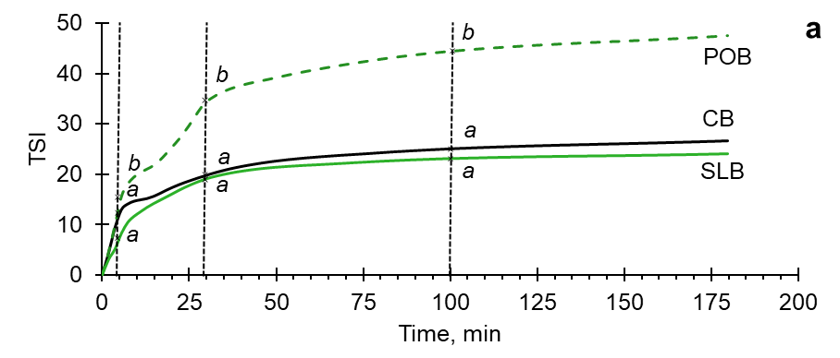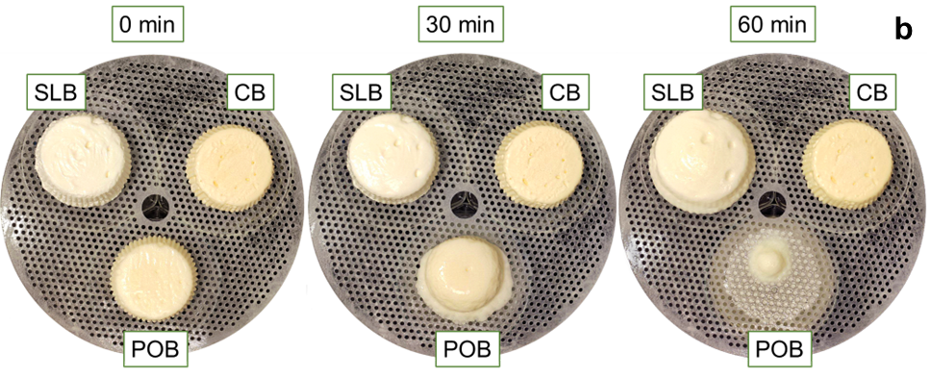
Figure 1: a) TSI index behaviour and b) images of the meltdown test of ice creams. Different letters in TSI graph indicated significant differences (p<0.05) between samples. POB: peanut-oil based ice cream; SLB: structured-lipid based ice cream; CB: cream-based ice cream.
The stability of the ice cream samples was determined by a multiple light scattering technique. Figure 1a shows the TSI index as a function of time. Higher values of the TSI (> 50) indicated instability phenomena occurring in the samples, while lower values (< 10) referred to highly stable samples. In the course of the 3 h measurement, the TSI values of the peanut-oil based sample were considerably higher (up to 48) than those of the other samples, ranging from 22–29, indicating the improved stability of structured ice cream formulations. This outcome could be once more explained by the presence of MAG crystalline structure formed during the glycerolysis in the structured-lipid based sample. This inhibited particle aggregation by creating a network with higher ice cream resistance to melting and structural failure.
Figure 1b shows the melting behavior of the three samples. Melting is a significant criterion when assessing the ice cream quality. The melting rate of the peanut-oil based ice cream was significantly higher (0.77 ± 0.042 g⋅min⁻¹) than that of the cream-based (0.017 ± 0.014 g⋅min⁻¹) and structured-lipid based (0.044 ± 0.021 g⋅min⁻¹) ice creams. As seen in Figure 1b, having the same fat content among the samples, the ice cream made with the structured peanut oil was more resistant to melting than the sample with the unstructured oil. The improved melting resistance was attributed to a higher water-binding capacity, ensured by a higher emulsification efficiency of the structured-lipid sample compared to the peanut-oil based ice cream (Sert et al., 2021; Góral et al., 2018)). Previous findings also shown that partial acylglycerides could counteract the lack of solid fat crystals at the surface of air cells, supporting partial coalescence and leading to a structure more able to hold its shape during ice crystals melting. Thus, creating a more stable matrix with a softer texture due to the entrapped air (Calligaris et al., 2018)..
3.3 Correlation between ice cream quality parameters
Figure 2 shows a correlation plot between the attributes of the blends and the ice creams textural and melting properties. Peanut oil- based blends reported significantly larger particles (D[3, 2]) highly correlated to high ζ-potential values. These attributes showed a positive correlation with ice creams having higher firmness and consistency. An inverse correlation was observed for the cohesiveness. Moreover, peanut oil-based samples with higher firmness reported a positive correlation with the TSI index, and the melting rate as they started to melt sooner compared to the other two samples.
On the other side, cream-based and structured-lipid based blends reported lower values of particle size diameters and ζ-potential. Both values were highly inversely correlated with cohesiveness, first dripping time and TSI values meaning that physical stable blends with lower diameters and ζ-potential produced ice creams with a more cohesive structure which tended to melt slower.

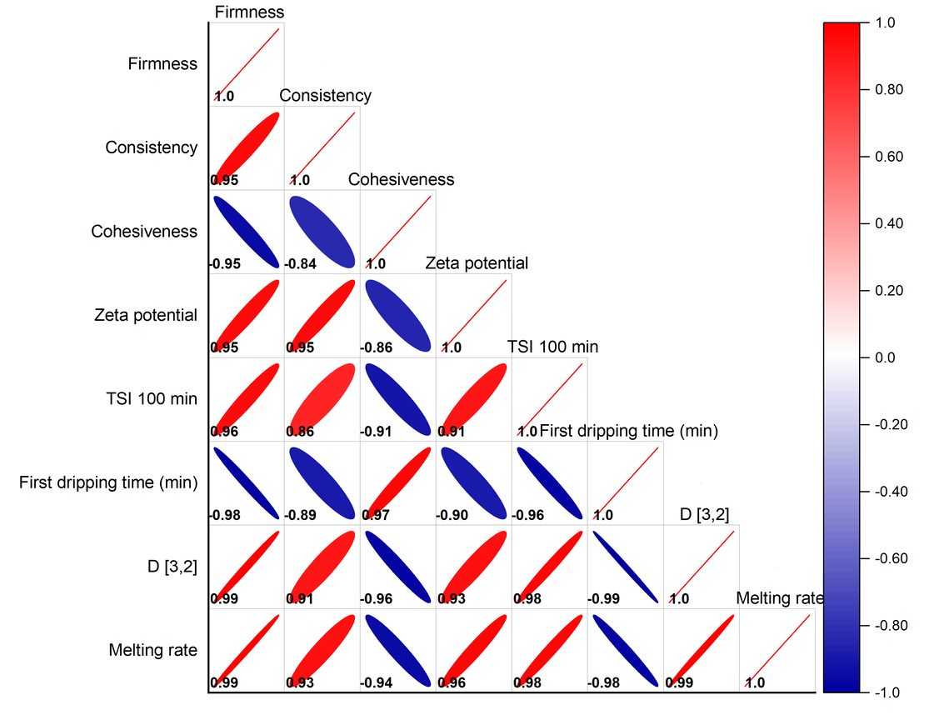
Figure 2: Correlation plot of blends and ice cream quality parameters.
These results were in agreement with previous findings demonstrating that the properties of the ice cream were significantly diminished when liquid oil was used to substitute milkfat in the formulation. This effect was thought to be caused by the absence of solid fat crystals on the air cell surfaces, which limited partial coalescence and made the structure less stable when ice crystals melted (Calligaris et al., 2018).
  - Conclusions
Structured lipids used as a fat source in the ice cream formulation greatly affected the physical properties of the product when compared to the one prepared with the unstructured oil. Indeed, the ice cream made with structured lipids showed a slower melting rate, softer, and more cohesive structure. Compared to the classical milk cream-based ice cream, the product formulated with structured peanut oil showed similar quality parameters. Thus, the obstacles related to the milkfat substitutions with vegetable oils were successfully overcome by using an oil structured with a glycolysis process. The results here reported represented the first step on the use of structured vegetable oils obtained from glycerolysis as possible alternative to fats rich in saturated fatty acids On the other hand, more studies are needed to assess the consumers perception of the newly formulated product.

Acknowledgments
The authors are thankful to A. Loacker Spa, Unterinn, Italy, for support during the development of this work. Award Number: Project code PE00000003, Concession Decree No. 1550 of 11 October 2022 adopted by the Italian Ministry of University and Research, CUP D93C22000890001, Project title “ON Foods - Research and innovation network on food and nutrition Sustainability, Safety and Security – Working ON Foods”. Project funded under the National Recovery and Resilience Plan (NRRP), Mission 4 Component 2 Investment 1.3 - Call for tender No. 341 of 15 March 2022 of Italian Ministry of University and Research funded by the European Union – NextGenerationEU.
References
Beegum P.P.S., Nair J.P., Manikantan M.R., Pandiselvam R., Shill S., Neenu S., Hebbar K.B., 2022, Effect of coconut milk, tender coconut and coconut sugar on the physico-chemical and sensory attributes in ice cream, Journal of Food Science and Technology, 59(7), 2605–2616.
Calligaris S., Marino M., Maifreni M., Innocente N., 2018, Potential application of monoglyceride structured emulsions as delivery systems of probiotic bacteria in reduced saturated fat ice cream, LWT, 96, 329–334.
FAO, 2010, Fats and fatty acids in human nutrition. Report of an expert consultation, Food and Nutrition Paper, 91:1-166.
FDA, 2016, CFR—Code of Federal Regulations Title 21. Chapter 1—food and drug administration Department of Health and Human Services – subchapter F—food for human consumption, Part 135—Frozen Desserts <https://www.accessdata.fda.gov/scripts/cdrh/cfdocs/cfcfr/cfrsearch.cfm?fr=135.110.> accessed 10.02.23.
Goff H.D., Hartel R.W., 2013, Ice cream, seventh edition. Ice Cream, Seventh Edition, 1–462.
Góral M., Kozłowicz K., Pankiewicz U., Góral D., Kluza F., Wójtowicz A., 2018, Impact of stabilizers on the freezing process, and physicochemical and organoleptic properties of coconut milk-based ice cream, LWT, 92, 516–522.
Nicholson R.A., Marangoni A.G., 2020, Enzymatic glycerolysis converts vegetable oils into structural fats with the potential to replace palm oil in food products, Nature Food 2020 1:11, 1(11), 684–692.
Nicholson R.A., Marangoni A.G., 2021, Lipase-catalyzed glycerolysis extended to the conversion of a variety of edible oils into structural fats, Current Research in Food Science, 4, 163–174.
Roy S., Hussain S.A., Prasad W.G., Khetra Y., 2021, Effect of emulsifier blend on quality attributes and storage of high protein buffalo milk ice cream, LWT, 150, 111903.
Sert D., Mercan E., Kılınç, M., 2021, Development of buffalo milk ice-cream by high pressure-homogenisation of mix: Physicochemical, textural and microstructural characterisation, LWT, 150, 112013.
USDA, 2015, Dietary Guidelines for Americans 2020–2025 Make Every Bite Count With the Dietary Guidelines, 9th ed. Washington DC, USA: US Government Publishing Office, <DietaryGuidelines.gov, https://www.dietaryguidelines.gov/sites/default/files/2020-12/Dietary_Guidelines_for_Americans_2020-2025.pdf> accessed 02.02.23.
Yan G., Cui Y., Lia D., Ding Y., Han J., Wang S., Yang Q., Zheng H., 2022, The characteristics of soybean protein isolate obtained by synergistic modification of high hydrostatic pressure and phospholipids as a promising replacement of milk in ice cream, LWT, 160, 113223.
Zhu X., Li L., Li S., Ning C., Zhou C., 2019, l–Arginine/l–lysine improves emulsion stability of chicken sausage by increasing electrostatic repulsion of emulsion droplet and decreasing the interfacial tension of soybean oil-water, Food Hydrocolloids, 89, 492–502.

